Village Show Software Guide

Contents
Getting Started 1
Using the Application 2
First time setup 2
Setting up for a new year 3
Day before the show 5
Show Day 6
Installing the platform and application 8
Example – Docker Desktop on Windows 8

Getting Started
The application is accessed from a browser that connects to the backend running in a kubernetes cluster. For the purpose of this guide, it is assumed that this is a local cluster, exposing the application at http://vshow.local.
- If this is a new computer - follow the instructions for installing the platform and then the application.
- Start the Docker Desktop application.
This application can use large amounts of resources, so should be shut-down when not in use.
Also check Settings (cog) and disable ‘Background SBOM Indexing’, this job can also eat resources and cause the machine to become unresponsive.
It is ready when the docker and Kubernetes status is green.
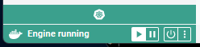
- Open a browser at http://vshow.local/
The following page shows
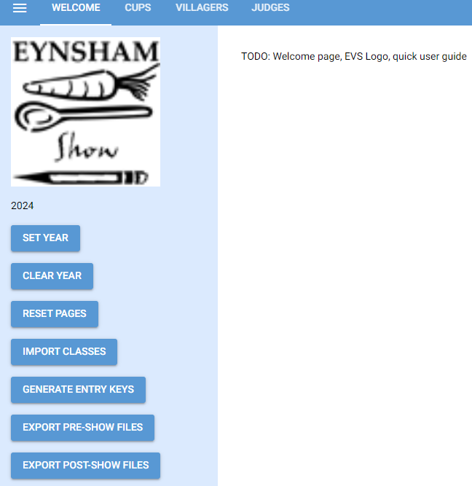
- Congratulations, you are ready to start!

Using the Application

First time setup
The first time the application is used it will create an empty database, add records to the YEAR table, and update the CURRENT_YEAR.
The user will need to enter the CUPS.

Cups Page
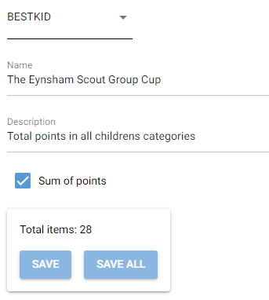
The Cups page uses a drop-down box for creation/search. Typing in the first box will filter matching items which can be selected, pressing ’enter’ will add the current item to the drop-down, and then that can be selected (to create a new entry). The editable items are:
- CUP key: This is a short name used for referencing the CUP during the import, so should be short and informative. It needs to be unique, and not include a comma.
- Name: The name of the cup.
- Description:
- Sum of Points: There are two mechanisms to award a cup, the ‘Sum of Points’ will aware the cup to the person who aggregates the highest core in the linked classes. ‘Sum of Points’ should also be used to identify a cup with only a single class, i.e. the winner of that class will also win the cup. If this is unchecked then the second mechanism ‘Direct Pick’ is used, and the judge will need to identify which entry from a range of classes should qualify.
- After entering any changes, the Save/Save All buttons will become active. Clicking on these will persist the data to the backing database, not clicking the save will mean the data is lost after the app resets. Conversely there is a ‘Reset Pages’ in the control bar, that will refresh all pages to the database stored state.

Setting up for a new year
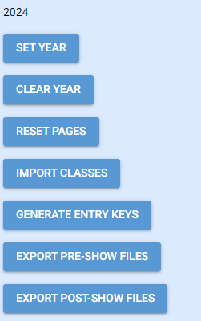
Each time the application restarts (i.e. because docker desktop restarted, or a redeployment) then the YEAR will be set to the current YEAR.
The ‘SET YEAR’ task allows the user to change to another year, the only time this is required is to review previous years data.
The ‘CLEAR YEAR’ task wipes ALL year associated data (i.e. only Cups and Villager names remain). Only use when testing up if the data for the IMPORT CLASSES has changed. In the future this will require a second click to protect the data.
‘RESET PAGES’ reverts all the pages in the UI back to what is saved in the database, use if data has been mistakenly entered.

IMPORT CLASSES
The user will need to create the class import file, and save it in c:/vshow/mounts/files/in.
The filename is not important, though <year>.csv is suggested.
The file must be in CSV format, and particularly in excel csv dialect, i.e. comma-separated, headers are included and fields including a comma will be wrapped with a double quote. Only the ClassName column should include a comma, while the import will still work, other parts of the app may fail.
The file is required to have the following layout:
Class | Name | Description | Kids | Judge | Cup1 | Cup2 | Cup3
1 | A bunch of Mixed Herbs |  | N | Fruit & Veg | BEST
2 | A Bucket of Compost |  | N | Fruit & Veg | BEST | COMPOST
- The first 5 columns (Class … Judge) must have those headers in that order, the following columns can be any number of columns (their headers are ignored).
- Column 1: Class. This is an integer value and unique in this file.
- Column 2: Name. The class name is the name of the category, and what appears on certificates. The class name is unique in this page (when combined with the ‘Kids’ flag), i.e. both adults and kids can have ‘Garden on a Plate’, but there can’t be two kid’s ‘Garden on a Plate’ (those will need to be e.g. ‘Garden on a Plate (4-7y)’).
- Column 3: Description. A more detailed description of this category, this appears in some result pages to aid announcements.
- Column 4: Kids. A flag to mark whether this is a kids class (y or Y). An adult cannot entry a kids class.
- Column 4: Judge. The judging category, each category represents the classes to be evaluated by a single judge.
- Column 5+: Cups. Provide a list of the CUPS that include this class (either as an aggregate points, or from where an entry can be picked). These items must already exist in the CUPS page.
Use the ‘Import Classes’ to pick the file, and a notification will appear in the UI (short lived banner, centre bottom), to indicate if it was successful or what was the issue.
The data can be checked:
- In the CUPS page, the categories associated with a cup is now shown.
- In the Judges page, Judge categories can be seen, with placeholders for results.
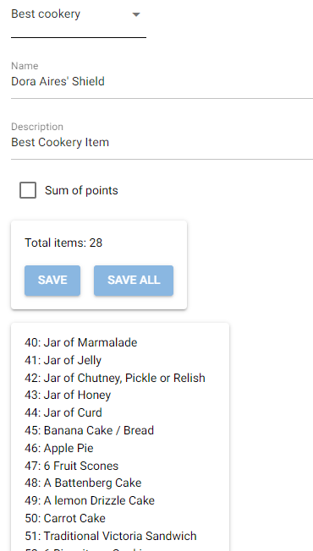 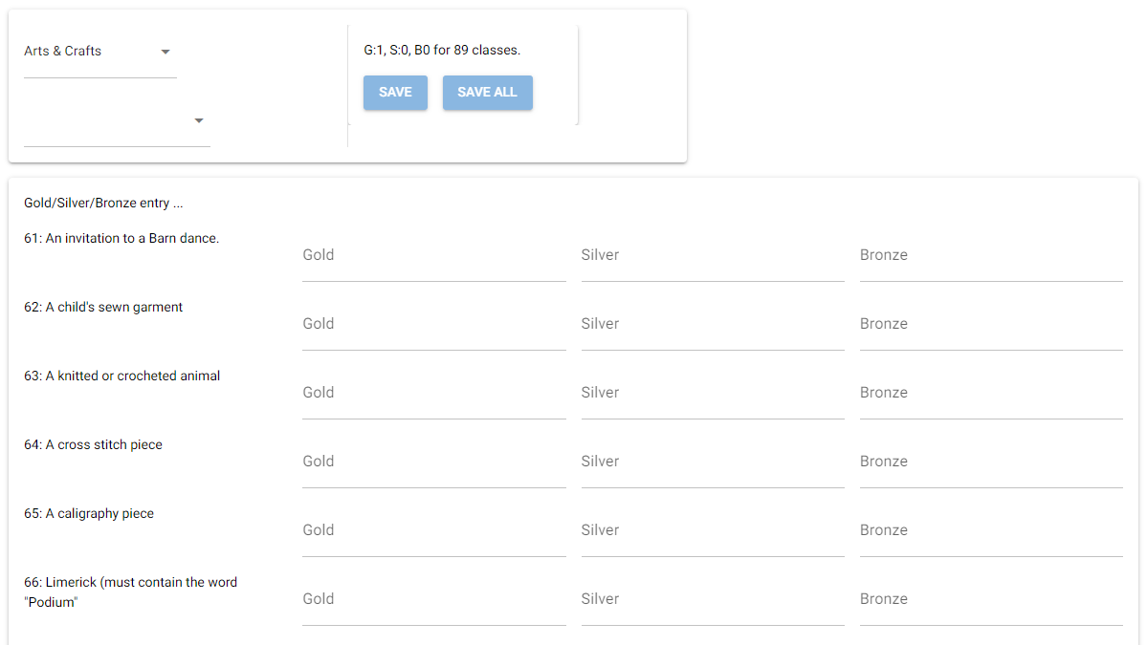

Day before the show

Set-up Villagers and Entries
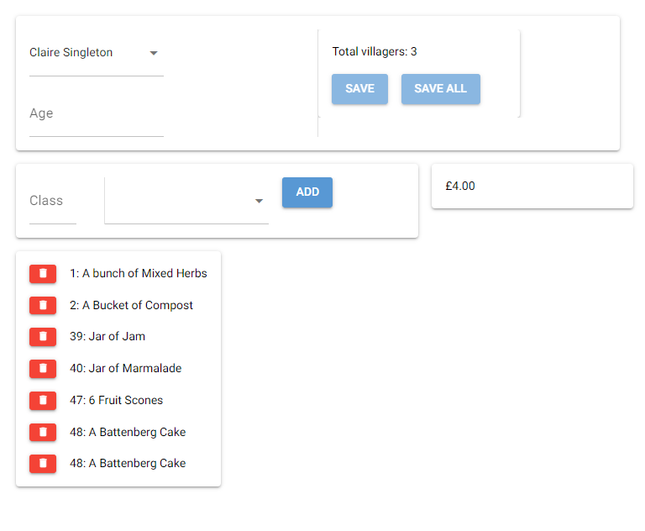
Add villagers into the VILLAGERS page. The first ‘name’ box allows search or creation of a villager: typing in the box will filter matching entries which can then be picked from the list, if not found then pressing ‘enter’ will add the villager to the list, which then needs to be picked to create a new entry.
The ‘age’ is required for children entries, it is their age at the this show, and needs to under 18 to qualify for child categories. (The data is saved as the year they will become an adult, so will increment each year).
The Class Entry can be achieved in two ways:
- Fast number entry … key a class number into the Class box and press return, it is added to the list.
- Look-up, pick and item from the list (of start typing to filter), pick the item and use the ‘Add’ button.
In both cases, the item is appended to the list with a ‘bin’ icon to delete it.
A running total of the cost of this entry is shown. (Adult £1 first entry, 50p remaining, Children 50p per entry).
The Save / Save all buttons become active once there are changes. Remember to save changes to the database regularly.
Note that Judges are also villagers, please add their names here (the entry list can be empty),

Update Judges
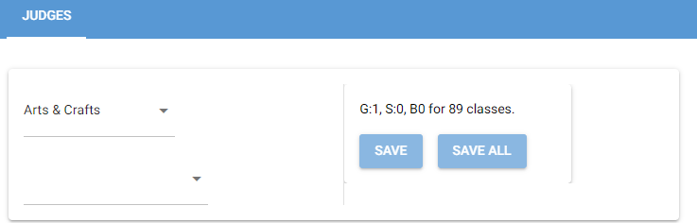
In the judges page, select the villager name from the second drop-down (and save).

Generate the Entry Keys
Once all items have been entered then use the GENERATE ENTRY KEYS button to assign secret hashes to every entry. These are the anonymous codes that will be on the stickers for each entry, marked onto the judged forms, and entered into the database.
If additional changes are made (e.g. late entry forms), then the Keys will need to be regenerated.
Key regeneration also wipes any existing judge entries (there shouldn’t be any at this stage)

Export Pre-Show Files
The Export Pre-Show File action builds all the resources required for the show, they will all be written to c:/vshow/mounts/files/out
- Entrants.docx is the Entrants Guide. One page (or more for longer entries) showing on the day instructions, their entered category list and anonymous codes. Once printed this should be split by entrant, and added to the welcome envelope.
- Lables.csv is a simple list of all the entrants. This is used in the mail merge to print the welcome envelope labels. Claire to fill in details about this merge.
- Sticker.csv is a list of all the entries. This is used in the mail merge to print the collection of stickers. Claire to fill in details about this merge. Once printed, these stickers are to be divided and added to the welcome envelopes, note that the stickers only have a category and anonymous code, but they are in the same order as the Entrants.docx, so should be simple to divide.
- Judges.docx is the Judges Guide. One page (or more for overloaded judges) showing the judging instructions, categories to mark for Gold / Silver/ Bronze, and optionally a list of cups that require the judge to pick an entry.

Show Day

Judging
The Judges Guide is handed to each judge, and their helper enters the entry ref (a set of two, not easily mistaken chars) into the Gold / Silver / Bronze areas, and similar into the Cup area.

Input the Results Data
The Judges page has a box for each required input (they can be left blank if their aren’t enough entries). The two character code is entered in each box (it is validated that that code relates to an entry that qualifies in this class). A total of Gold / Silver / Bronze progress is shown at the top.
The Judges page may also have a second entry card, this is where ‘pick an entry for this Cup’ is entered.
Remember to save!

Generate the Post-Show Files
The Generate Post-Show files action builds all the resources required for the awards, they will all be written to c:/vshow/mounts/files/out:
- The certificate mail-merge source files (gold/silver/bronze.csv). Claire to fill in details about this merge.
- Cup_data_raw.csv list all the cups and what entries related to them, and who got gold/silver/bronze (for points), and who was select for what category (cup type).
- Cup_data_pts.csv shows all points cups, and the totals scored by each person (who has scored at least 1 point for that cup). This can be used to check how close some of the races were.
- Cup_data.csv is the simple list of all cups, and who won what (and the category of the ‘best in …’ ).

Installing the platform and application
We’ll assume that the user is using a Windows machine, and is building the application on Kubernetes running in Docker Desktop (using WSL), with a containerised PostGres, and a localhost url using nginx ingress.

Example – Docker Desktop on Windows

Install WSL (Windows Linux)
WSL is a feature that allows a linux image to run in windows.
In Powershell
wsl –install
This will install and start-up a linux image, just accept all defaults, then close the image down.

Install Docker Desktop
Docker Desktop is an application that enabled building, and running, of containers.
Install Button: https://docs.docker.com/desktop/install/windows-install/
If prompted select WSL2
Open docker desktop (to start the docker daemon)
(In Settings [cog]) Disable background BSOD indexing!
(In Settings [cog]) Enable kubernetes (restart as required)

Install CygWin
CygWin provides a linux terminal running in Windows.
See https://www.cygwin.com/install.html.
This downloads an exe, then run that an select ‘internet install’ and select a mirror (any UK one is good).

Install Kubectl
Kubectl is a command line program that allows interaction with the Kubernetes environment.
This is probably not required, the Docker Desktop process should create it.
To check (in CygWin):
kubectl config get-contexts
(This should show the docker desktop context)

Install Helm
Helm is a Kubernetes packaging manager, we will use Chocolatey to install it in Windows.
In Powershell:
Get-ExecutionPolicy
# If it returns Restricted, then run Set-ExecutionPolicy AllSigned
# Install Chocolatey
Set-ExecutionPolicy Bypass -Scope Process -Force; [System.Net.ServicePointManager]::SecurityProtocol = [System.Net.ServicePointManager]::SecurityProtocol -bor 3072; iex ((New-Object System.Net.WebClient).DownloadString('https://community.chocolatey.org/install.ps1'))
# Install Helm
choco install kubernetes-helm

Add Required repos to Helm
In Cygwin:
helm repo add bitnami https://charts.bitnami.com/bitnami
helm repo add runix https://helm.runix.net

Install NginX
NginX is a reverse proxy in kubernetes, i.e. it can be used to route traffic to the cluster over to the correct container.
In Cygwin:
helm install nginx oci://ghcr.io/nginxinc/charts/nginx-ingress --version 1.1.3 -n kube-system
# Edit the hosts file to map some addresses. Use notepad to edit the file c:/Windows/System32/drivers/etc/hosts, and add the following:
127.0.0.1 pgadmin.local # PGAdmin
127.0.0.1 vshow.local # web server

Set-up some Kubernetes resources
In Cygwin:
cd /cygdrive/c/vshow/k8s
# Create a namespace (an area where all the vshow objects will exist)
kubectl create namespace vshow
# Create the volumes, these make c:/vshow/mounts/[files|db|pga] available to Kubernetes.
kubectl apply -f pv.yaml

Install and configure PostGres
In Cygwin:
cd /cygdrive/c/vshow/k8s
helm install db bitnami/postgresql -n vshow -f pg-values.yaml
# After a while, check the postgres container
kubect -n vshow get pod db-postgreql-0
# This should show ‘Running#
kubectl -n vshow logs db-postgreql-0
# This should show no errors, if there are ‘postgres user does not have a password’ issues then see the fix later.

[Optional] Install and configure PGAdmin
PGAdmin is a tool that allows a user to view the database via a web-browser, this is useful for development and debugging.
In Cygwin:
cd /cygdrive/c/vshow/k8s
helm install pga runix/pgadmin4 -n vshow -f pga-values.yaml
In a browser, http://pgadmin.local should now be available, login as pgadmin/evspassword.
Right-click on servers to ‘add a server’
Name: vshow
Connection: db-postgresql
Port: 5432
User: postgres
Password: postgres
That should connect and allow a drill down into the database objects.

Build the Village Show application
This ‘docker build’ step will generate a container image that can run the ap, i.e. a linux container with python and the required modules installed, and the source code.
In Cygwin:
cd /cygdrive/c/vshow/docker
docker image build . -t singjoh/vshow:latest

Deploy the Application and Config Items
These items set-up the application to work with Kubernetes, power users can edit these.
In Cygwin:
cd /cygdrive/c/vshow/k8s
# Install the config map, these are the configuration details that the vshow app will use to connect to the database (the none secret items). If you use an external database, alternative user, then adjust here.
kubectl apply -f cm.yaml
# Install the secrets, these are the passwords for the database. The user requires admin (create database) on first run, but then just needs CRUD permissions on the vshow database.
kubectl apply -f secret.yaml
# Install the ingress. An ingress pipes incoming web traffic to the correct service. This sets-up ‘vshow.local’ to go to the vshow service. (the pgadmin ingress, pgadmin.local, is built into its installation)
kubectl apply -f vshow.ing.yaml
# Install the service. A service associates a name with a container using a selector, i.e. the pod name can change after a restart, but the service will then link to the new name. An ingress points to a service.
kubectl apply -f vshow.svc.yaml
# Install the pod, this contains the details to run the application, i.e. the docker image, the mounted drives, and loads up the config map and secrets.
kubectl apply -f vshow.pod.yaml

The application should now be available at http://vshow.local

Redeploy
After this has all neem set-up, and some code has been changed, then it can be deployed simply.
In CygWin:

Note, after code changes the new code can be deployed simply using (in Cygwin):
cd /cygdrive/c/vshow/docker
./redeploy
# that rebuilds the image, stops/starts the container (the ui will lose connection at this stage), and the tails the log file.

